**ASSIGNMENT - 7**

**-- 1.Rank employees by their total sales**

**-- (Total sales = Total no of orders handled, JOIN employees and orders table)**

SELECT

e.employee_id,

CONCAT(e.first_name, ' ', e.last_name) AS employee_name,

COUNT(o.order_id) AS total_orders,

RANK() OVER (ORDER BY COUNT(o.order_id) DESC) AS sales_rank

FROM employees e

JOIN orders o ON e.employee_id = o.employee_id

GROUP BY e.employee_id, e.first_name, e.last_name

ORDER BY sales_rank;

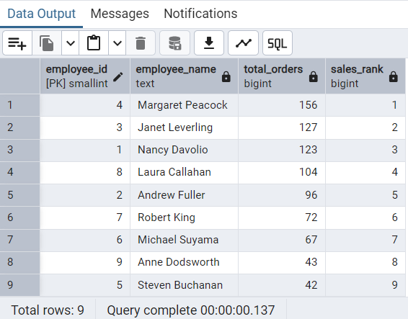

-------------------------------------------------------------------------------------------------------------------------------

**-- 2.Compare current order's freight with previous and next order for each customer.**

**-- (Display order_id, customer_id, order_date, freight,**

**-- Use lead(freight) and lag(freight).**

SELECT

order_id,customer_id,

order_date,freight,

LAG(freight) OVER (PARTITION BY customer_id ORDER BY order_date) AS previous_freight,

LEAD(freight) OVER (PARTITION BY customer_id ORDER BY order_date) AS next_freight

FROM orders

ORDER BY customer_id, order_date;

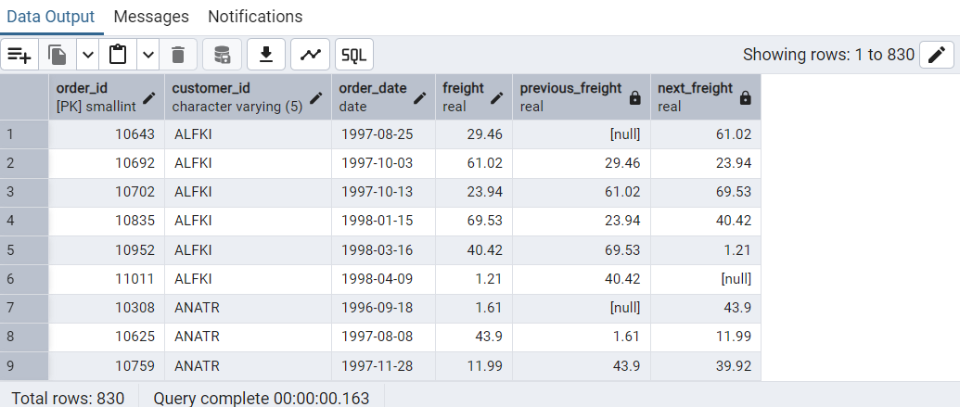

-------------------------------------------------------------------------------------------------------------------------------

**-- 3.Show products and their price categories, product count in each category, avg price:**

**/*(HINT:**

**· Create a CTE which should have price_category definition:**

**WHEN unit_price < 20 THEN 'Low Price'**

**WHEN unit_price < 50 THEN 'Medium Price'**

**ELSE 'High Price'**

**· In the main query display: price_category, product_count in each price_category, ROUND(AVG(unit_price)::numeric, 2) as avg_price)*/**

WITH cte_price AS (

SELECT

product_id,product_name, unit_price,

CASE

WHEN unit_price < 20 THEN 'Low Price'

WHEN unit_price < 50 THEN 'Medium Price'

ELSE 'High Price'

END AS price_category

FROM

products

)

SELECT

price_category,

COUNT(*) AS product_count,

ROUND(AVG(unit_price)::numeric, 2) AS avg_price

FROM cte_price

GROUP BY price_category

ORDER BY avg_price;

